WHERE-TO-BE / WHAT-TO-DO
2017 SOLAR CAR CHALLENGE
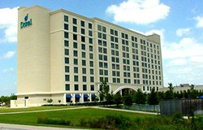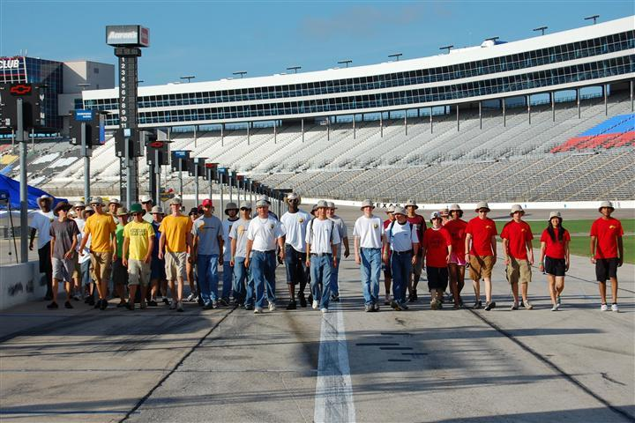
Saturday
July 15 .
10:00 AM Judges Training Workshop [10:00 AM – 3:00 PM]
Colorado Room, DFW Marriott
Lunch provided

1:00 PM Teams Check-In [1:00 PM – 7:00 PM]
Teams will be assigned a time to arrive for Team Check-In
Pecos Room, DFW Marriott
All race participants must attend Team Check-In

Teams need to bring the following:
- SCC Release of Liability Form signed by parents
- TMS Release of Liability Forms (adult and minors)
- All drivers verify their driver’s licenses [Driver Check-In]
[Wristbands awarded when driver completes Scrutineering Station 4]
- Teams with more than 14 people (students, teachers, chaperones) make arrangements for “extra person fee”
- Purchase tickets for Awards Banquet - $35/person
- Supply documents to complete Final Race Registration packet
- Turn in Solar Car Liability Insurance Certificate
- Bring a radio you plan to use during the race
- Non-digital scrapbooks will be turned in at Oral Presentations
Teams will receive:
(1) 14 tee shirts
(2) 50 Official Race Booklets
(3) Traditional “baking soda” for environmental spills
(4) Rule Booklet and “Final Where-to-Be What-to-Do” Document
(5) Official Scrutineering Packet
(6) Race Identification badges for all race participants
(7) Draw for Starting Order, Garage, Pit Row, Oral Presentation
(8) Scoring Tablet

7:00 PM Pre-Race Orientation – Required for all Race Participants
Trinity Ballroom I, DFW Marriott

8:00 PM Required Team Safety Officer Meeting [required]
Trinity Ballroom I, DFW Marriott

8:00 PM Drivers Meeting [required]
Colorado Room, DFW Marriott

9:00 PM Team Spotters Meeting
Colorado Room, DFW Marriott

9:00 PM Radio Operators Meeting [required]
Trinity Ballroom I, DFW Marriott
Sunday
July 16
6:30 AM Judges Meet at Garages for Scrutineering

7:00 AM Scrutineering Day One
Teams get access to Texas Motor Speedway. Staff will show
teams their designated garage and pit row space .

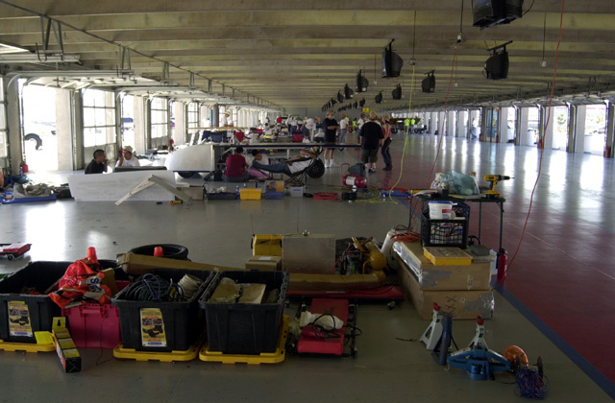

8:00 AM Scrutineering Session No. 1 [8: 00 AM – 6:00 PM]
All cars must be ready to begin Scrutineering at 8:00 AM or will receive a penalty. [Rule 7.1]

12:30 PM The SCC will provide Dominos Pizza for teams
West End of the CUP Garage

6:00 PM Garages close
[If you need to work on your solar car overnight, you can always take your car back to the hotel to work in the hotel parking lot.]

7:00 PM Race Staff Meeting
Guadalupe Room, DFW Marriott

8:00 PM Special Demonstration/Workshop for Solid Edge CAD Program
Teams should send representatives to this workshop
Hosted by Lar Naunheim, Siemens Solid Edge Software
Trinity Ballroom III, DFW Marriott

9:00 PM Workshop: Importance of Information Analysis in Solar Car Races
Teams should send representatives to this workshop
Hosted by Jarrett Dunn, Special Advisor to the Race Director
Trinity Ballroom III, DFW Marriott
Monday
July 17
6:30 AM Judges meet at Garages for Scrutineering

7:00 AM Scrutineering Day Two
Teams get access to Texas Motor Speedway

8:00 AM Scrutineering Session No. 2 [8: 00 AM – 6:00 PM]

10:00 AM Oral Presentations Session [10:00 AM – 5:00 PM]
Teams submit their non-digital Scrapbook for evaluation
Media Center, Texas Motor Speedway

6:00 PM Garages Close

7:30 PM Opening Banquet
Trinity Ballroom, DFW Marriott Hotel at Champions Circle
- Team Captains need to be prepared to introduce team members, teacher/sponsor, and guests.
- Announce Jarrett Dunn Team Scholarship Award
Tuesday
July 18
6:30 AM Judges meet at Garages for Scrutineering

7:00 AM Scrutineering Day Three
Teams get access to Texas Motor Speedway

8:00 AM Scrutineering Session No. 3 [8: 00 AM – 6:00 PM]
Teams not qualifying by 6:00 PM will not be able to take part
in the 2017 Solar Car Challenge.

10:00 AM Media Day Events at Texas Motor Speedway
Teams must have their solar car and team members on display
and available to meet media North of the Media Center. We will
take the Official Race Photo at this time.
[Scrutineering suspended until 12:00 PM]

Meet representatives from Texas A&M Engineering Academies
Media Center, Texas Motor Speedway

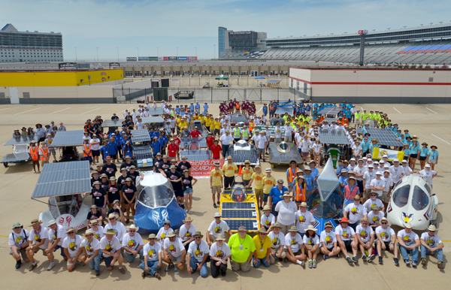

12:30 PM The SCC will provide Dominos Pizza for teams
West End of the CUP Garage

6:00 PM Official Scrutineering Ends
Garages Close

7:30 PM Ice Cream Social
Hosted by Liberty Christian Academy
1301 US-377, Argyle, TX 76226

Wednesday
July 19
6:30 AM Teams get access to Texas Motor Speedway.
Judges will meet teams at the CUP Garage.

7:30 AM “Forever Laps” posted on Media Center Door

8:00 AM Required Teams Meeting
West End of CUP Garage

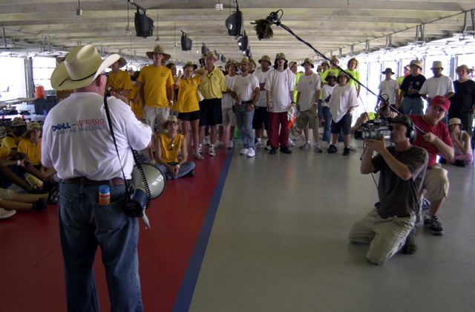

8:45 AM Solar Cars lined up in pit row for RACE START
Starting Order based on Team Check-In Drawing. Teams start racing every minute. Any team not ready at their prescribed time will take a position at the end of the Starting Order Line.

8:50 AM OPENING CEREMONIES

9:00 AM FIRST RACE DAY BEGINS – All Divisions

RACING PERIODS:
Classic Division and Electric-Solar Power Division vehicles will race from 9:00 AM – 12:00 PM, and 2:00 PM – 5:00 PM. The Advanced Division vehicles will race from 9:00 AM – 5:00 PM with a required 30 minutes off-track rest period. Teams must use all of their 30 minutes at one time.

12:00 PM End of racing for Classic Division and Electric-Solar
Powered Division vehicles

1:45 PM Classic and Electric Vehicles lined up in pit row for Re-Start

2:00 PM Racing resumes for Classic Division and Electric-Solar
Powered vehicles

5:00 PM END RACING DAY FOR ALL VEHICLES.
Teams come off track in staggered order based on Starting Order

6:00 PM Solar Car Challenge provides a Texas Bar-B-Q Dinner
West end of the CUP Garage

7:00 PM Judges Meeting – Media Center

9:00 PM Vehicles Impounded in Texas Motor Speedway Garages.
[Teams have no more access to solar cars]
Thursday
July 20
6:30 AM Teams get access to Texas Motor Speedway.
Judges will meet teams at the CUP Garage.

8:00 AM Required Teams Meeting
West End of CUP Garage

8:45 AM Solar Cars lined up in pit row for RACE START
The Starting Order in each division will be based on the official number of laps earned during the preceding day of racing. Teams start racing every minute. Any team not ready at their prescribed time will take a position at the end of the Starting Order Line.

9:00 AM SECOND RACE DAY BEGINS – All Divisions

12:00 PM End of racing for Classic Division and Electric-Solar
Powered vehicles

1:45 PM Classic and Electric Vehicles lined up in pit row for Re-Start

2:00 PM Racing resumes for Classic Division and Electric-Solar
Powered vehicles

5:00 PM END RACING DAY FOR ALL VEHICLES.
Teams come off the track in staggered order based on Starting Order

6:00 PM Solar Car Challenge provides a Mexican Food Dinner
West end of the CUP Garage

7:00 PM Judges Meeting

9:00 PM Vehicles Impounded in Texas Motor Speedway Garages.

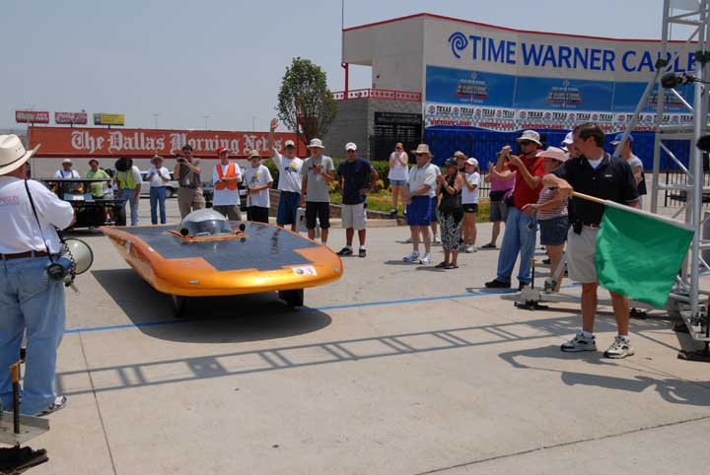

Friday
July 21
6:30 AM Teams get access to Texas Motor Speedway.
Judges will meet teams at the CUP Garage.

8:00 AM Required Teams Meeting
West End of CUP Garage

8:45 AM Solar Cars lined up in pit row for RACE START
The Starting Order in each division will be based on the official number of laps earned during the preceding day of racing. Teams start racing every minute. Any team not ready at their prescribed time will take a position at the end of the Starting Order Line.

9:00 AM THIRD RACE DAY BEGINS – All Divisions

12:00 PM End of racing for Classic Division and Electric-Solar
Powered vehicles

1:45 PM Classic and Electric Vehicles lined up in pit row for Re-Start

2:00 PM Racing resumes for Classic Division and Electric-Solar
Powered vehicles

4:00 PM END RACING DAY FOR ALL VEHICLES.
Teams come off the track in staggered order based on Starting Order

Be aware that there are other racing activities at the
Speedway after 6:00 PM. Use care about articles,
tent, chairs, etc. left on Pit Row.

6:00 PM Solar Car Challenge provides a Chopped Brisket Sandwich Dinner
West end of the CUP Garage

7:00 PM Judges Meeting

9:00 PM Vehicles Impounded in Texas Motor Speedway Garages

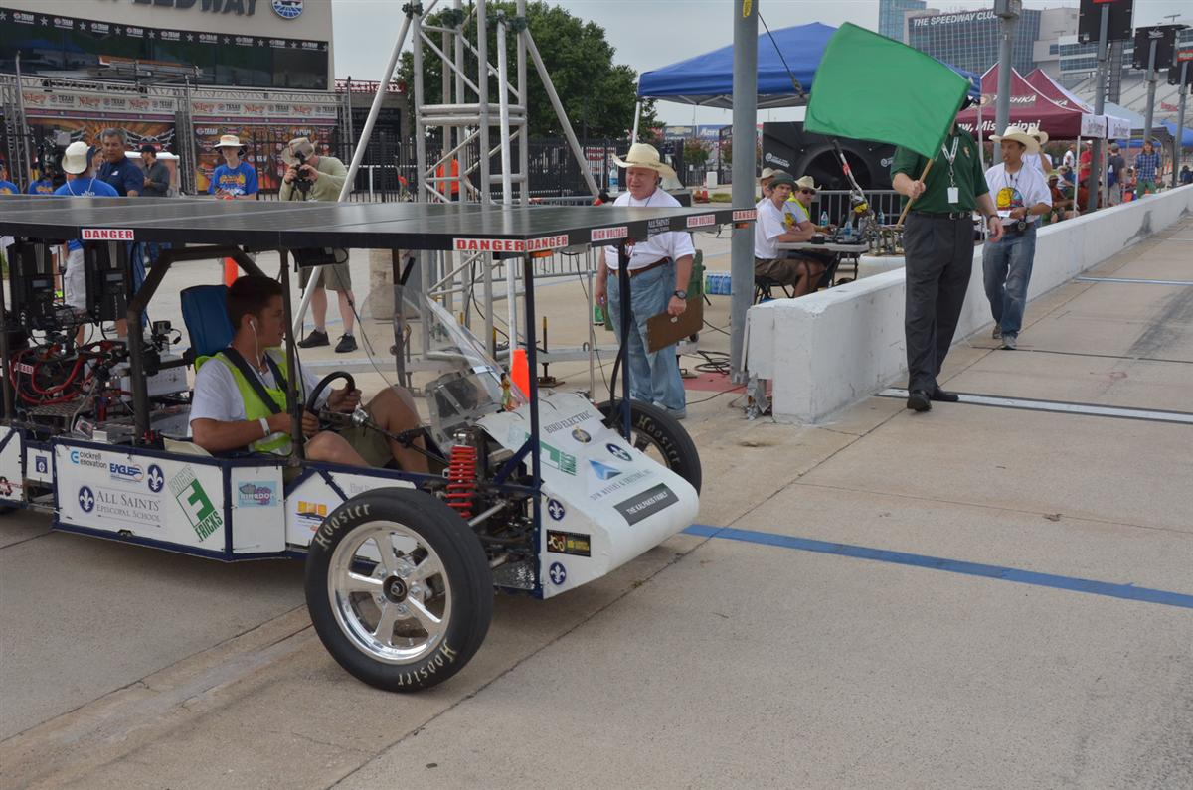
Saturday
July 22
6:30 AM Teams get access to Texas Motor Speedway.
Judges will meet teams at the CUP Garage.

8:00 AM Required Teams Meeting
West End of CUP Garage

8:45 AM Solar Cars lined up in pit row for RACE START
The Starting Order in each division will be based on the official number of laps earned during the preceding day of racing. Teams start racing every minute. Any team not ready at their prescribed time will take a position at the end of the Starting Order Line.

9:00 AM FOURTH RACE DAY BEGINS – All Divisions

12:00 PM End of racing for Classic Division and Electric-Solar
Powered vehicles

1:45 PM Classic and Electric Vehicles lined up in pit row for Re-Start

2:00 PM Racing resumes for Classic Division and Electric-Solar
Powered vehicles

4:00 PM END RACING DAY FOR ALL VEHICLES.
Teams come off the track in staggered order based on Starting Order

4:30 PM Teams leave Texas Motor Speedway for DFW Marriott. Everything must be out of the Garages by 5:00 PM.

TURN IN RADIOS AS YOU EXIT THE SPEEDWAY
Race Staff will get radios as you exit through the South Gate

7:30 PM AWARDS BANQUET [Purchase tickets in advance]
Ballroom, DFW Marriott

Team Captains will sit at a head table, and will be called on
to share their race experiences. Be prepared to make a one
minute speech! [Only one captain per team]

Please note that teams are responsible for their solar cars
parked overnight at the DFW Marriott.

